Muğla Sıtkı Koçman University

Department of Computer Engineering

Senior Design Project I

News App

Analysis & Design Report

Project Group Member Name, Project Group Member Name …

Ali Gökmen 190709016

Supervisor: Supervisor Name

January 3, 2020

**Contents**

1 Introduction 3

2 Motivation 3

3 Similar Existing Applications 3

4 Proposed System 3

4.1 Overview 3

4.2 Functional Requirements 3

4.3 User Interface Design 3

4.4 Entity Relationship Diagram 3

4.5 Technologies and Tools 3

5 Future Work 3

6 References 3

The News Application

# Introduction

Hi I m Ali Gökmen from Muğla Sıtkı Koçman University 4th grade student.Today I will talk about my news app which is my graduation project. In a world bustling with information, staying updated is not just a choice; it's an empowerment. News App brings you a curated and personalized news experience designed to keep you informed, inspired, and engaged.

**Motivation**

My aim is to make news consumption a delightful and personalized experience for everyone. I'm driven by the belief that staying informed should be easy and enjoyable.

**Key Features:**

**1. Multilingual News Access:**

Access news in the language that suits you best. News App lets you search and read news in your preferred language.

**2. Personalized News Feeds:**

Tailor your news feed to match your interests. Save favorite articles and adjust your reading experience to fit your preferences.

**3. Latest News in Six Categories:**

Stay updated across six diverse news categories, including breaking news, technology, entertainment, sports, and more.

**4. User Profiles:**

Make it personal by creating your own user profile. Add your name and profile picture to make News App uniquely yours.

**5. Search News Easily:**

Looking for specific news? Use our powerful search feature to find articles on topics that matter to you.

**6. Bookmark and Save:**

Found an interesting article? Save it for later. News App lets you bookmark and save articles for easy access.

My motivation is to redefine how news is consumed, making it not just a necessity but a pleasurable and enriching experience.

# Similar Existing Applications

(Cant reach to mobile apps links so I add similar existing websites instead of application link)

**Flipboard:**

What It Does: Flipboard is like a personal magazine for news. You can choose what you want to read, and it shows you stories in a magazine style.

Where to Find It: [Flipboard](https://flipboard.com/)

**Google News:**

What It Does: Google News gives you all the latest news. It learns what you like and gives you news that you'll find interesting.

Where to Find It: [Google News](https://news.google.com/home?hl=tr&gl=TR&ceid=TR:tr)

**Differences of News App:**

* Easy to use: users can easily use this app there is no complexity.
* Language: users can change the language of the app whenever they want.
* Searching News: users can search for articles in any available language.

# Proposed System

## Overview

Provide a figure and describe your project by explaining the figure.

## 

## Functional Requirements

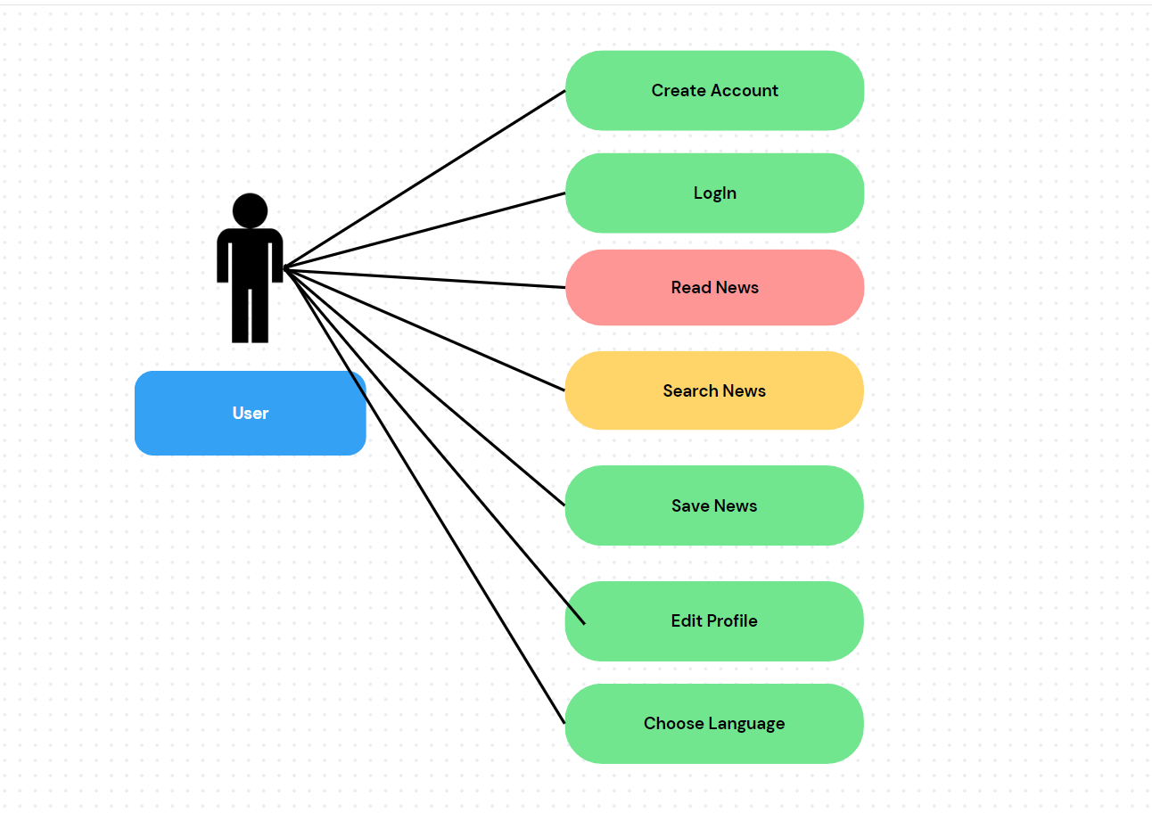Provide Use Case diagrams and List Use cases and their descriptions

Use Cases and Descriptions:

User Registration:

Description: Users can create accounts to personalize their experience.

User Login:

Description: Registered users can log in to access their personalized content.

Read News:

Description: Users can view news articles from various categories.

Search News:

Description: Users can search for specific news articles based on keywords in any language.

Save News:

Description: Users can bookmark and save articles for future reference.

Edit Profile:

Description: Users can update their profile pictures and their names

Choose Language:

Description: Users can change the language of the app any time they want.

## User Interface Design

List UI Mockups and their descriptions

Provide a youtube link to Wizard of Oz Video

(Instead of Creating a Design I used My own Design and Explain the Screens one by one)

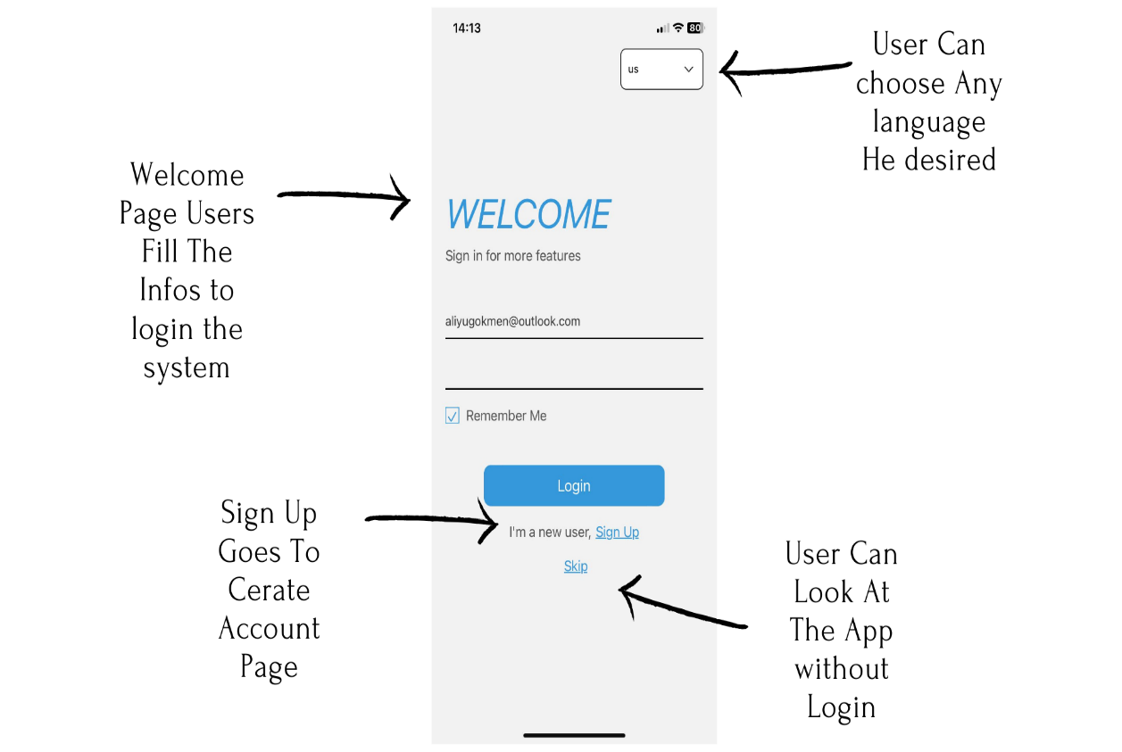

metin, ekran görüntüsü, yazı tipi, tasarım içeren bir resim

Açıklama otomatik olarak oluşturuldu

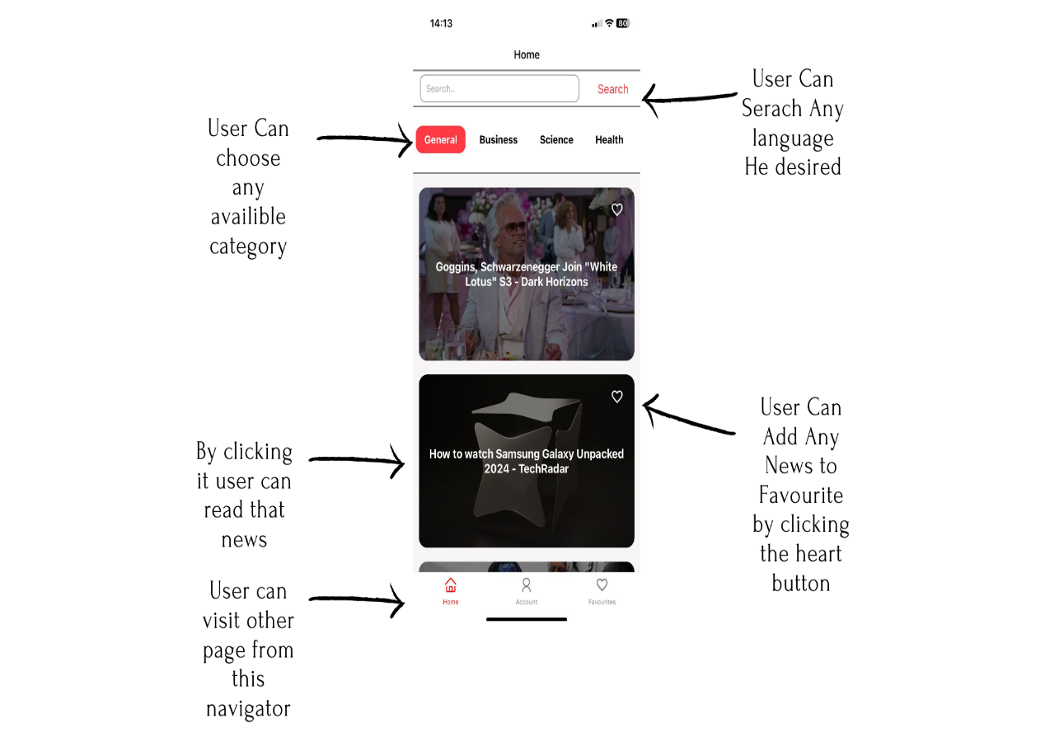

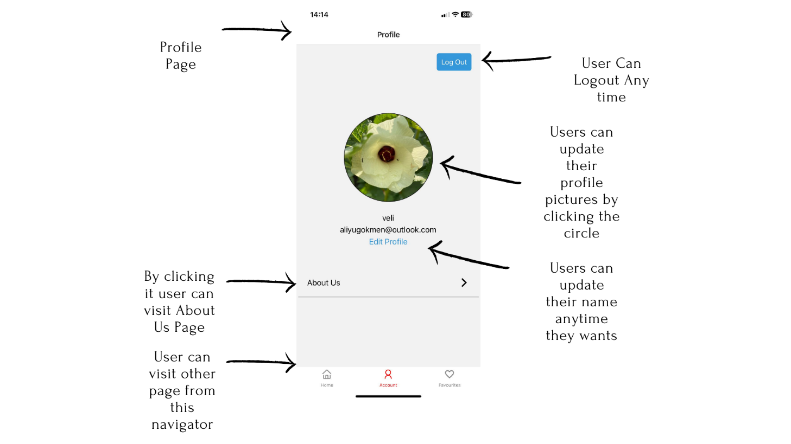

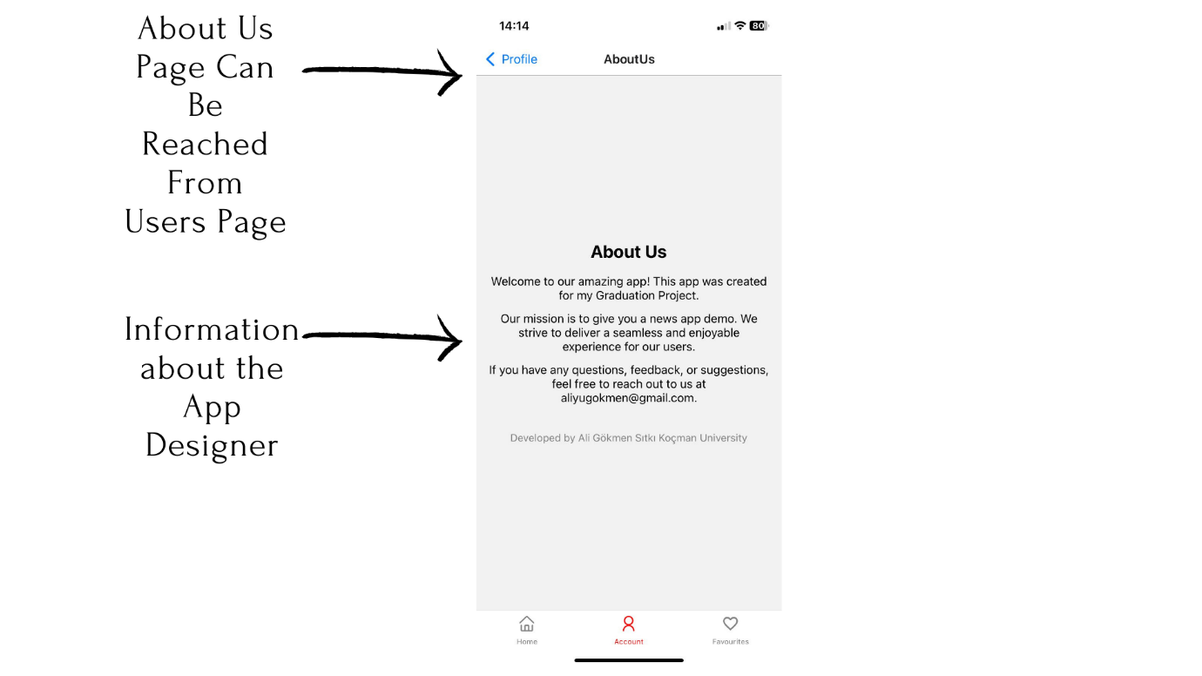

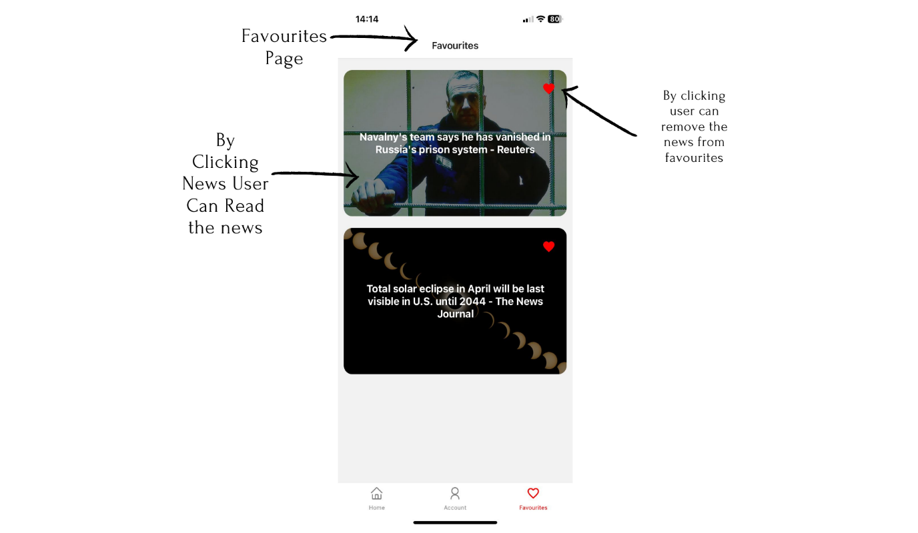

## Entity Relationship Diagram

Provide ER Diagram and describe each table and columns in the diagram

## 

## 

## Technologies and Tools

List the technologies and tools you are planning to use in your project. If you are inexperience in using them explain how you will learn using them.

**Frontend**: React Native

**Backend**: Node.js with Express

**Database**: FireBase RealTimeDatabase / Firebase Storage

**Authentication**: Firebase Authentication

**Version Control:** Git/GitHub

# Future Work

I planning to move the search into another page and put a navigation bar to access to it from bottom navigator. Also I plan to add comment section for each news for users but its hard to implement because I'm using a database from newsApi and to do this I need to upload every news to my database first and ect.. . Also, in Profile section I want to add a button so users can change their passwords. Finally a notification part for the app which tells the users a new App is break.

# References

Github Link: <https://github.com/gokmen123/News-App>

Resources that I used During Project:

Youtube:

<https://www.youtube.com/watch?v=QpfAyQgphgw&t=185s&pp=ygUQcmVhY3QgbmF2aWdhdGlvbg%3D%3D>

<https://www.youtube.com/watch?v=AnjyzruZ36E&pp=ygUecmVhY3QgbmF2aWdhdGlvbiB0YWIgbmF2aWdhdG9y>

<https://www.youtube.com/watch?v=ur6I5m2nTvk&list=PL4cUxeGkcC9ixPU-QkScoRBVxtPPzVjrQ>

<https://www.youtube.com/watch?v=5vA2ajlkLWI>

<https://www.youtube.com/watch?v=cdP210MwnLw>

<https://www.youtube.com/watch?v=1GpOS5mrGHI&list=PLQWFhX-gwJbmrCwksjn77tdl36dIWPFAt&index=7>